**NAME-TASMIYA FATHIMA**

**USN-1BM19CS172**

**LAB PROGRAM 4 (STUDENT FACULTY DATABASE)**

**QUERY**

**create database student;**

**use student;**

**create table student(**

**snum int,**

**sname varchar(10),**

**major varchar(2),**

**lvl varchar(2),**

**age int,**

**primary key(snum));**

**desc student;**

**create table faculty(**

**fid int,**

**fname varchar(20),**

**deptid int,**

**primary key(fid));**

**desc faculty;**

**create table class(**

**cname varchar(20),**

**meets_at timestamp,**

**room varchar(10),**

**fid int,**

**primary key(cname),**

**foreign key(fid) references faculty(fid));**

**desc class;**

**create table enrolled(**

**snum int,**

**cname varchar(20),**

**primary key(snum,cname),**

**foreign key(snum) references student(snum),**

**foreign key(cname) references class(cname));**

**desc enrolled;**

**insert into student values(1,'John','CS','Sr',19);**

**insert into student values(2,'Smith','CS','Jr',20);**

**insert into student values(3,'Jacob','CV','Sr',20);**

**insert into student values(4,'Tom','CS','Jr',20);**

**insert into student values(5,'Rahul','CS','Jr',20);**

**insert into student values(6,'Rita','CS','Sr',21);**

**commit;**

**select * from student;**

**insert into faculty values(11,'Harish',1000);**

**insert into faculty values(12,'MV',1000);**

**insert into faculty values(13,'Mira',1001);**

**insert into faculty values(14,'Shiva',1002);**

**insert into faculty values(15,'Nupur',1000);**

**commit;**

**select * from faculty;**

**insert into class values('class1','12/11/15 10:15:16','R1',14);**

**insert into class values('class10','12/11/15 10:15:16','R128',14);**

**insert into class values('class2','12/11/15 10:15:20','R2',12);**

**insert into class values('class3','12/11/15 10:15:25','R3',11);**

**insert into class values('class4','12/11/15 20:15:20','R4',14);**

**insert into class values('class5','12/11/15 20:15:20','R3',15);**

**insert into class values('class6','12/11/15 13:20:20','R2',14);**

**insert into class values('class7','12/11/15 10:10:10','R3',14);**

**commit;**

**select * from class;**

**insert into enrolled values(1,'class1');**

**insert into enrolled values(2,'class1');**

**insert into enrolled values(3,'class3');**

**insert into enrolled values(4,'class3');**

**insert into enrolled values(5,'class4');**

**insert into enrolled values(1,'class5');**

**insert into enrolled values(2,'class5');**

**insert into enrolled values(3,'class5');**

**insert into enrolled values(4,'class5');**

**insert into enrolled values(5,'class5');**

**commit;**

**select * from enrolled;**

**select distinct S.sname from student S, class C, enrolled E, faculty F**

**where S.snum = E.snum and E.cname = C.cname and C.fid = F.fid and F.fname = 'Harish' and S.lvl = 'Jr';**

**select C.cname from class C where C.room ='R128'**

**or C.cname in (select E.cname from enrolled E group by E.cname having count(*)>=5);**

**select distinct S.sname from student S where S.snum in**

**(select E1.snum from enrolled E1, enrolled E2, class C1, class C2 where**

**E1.snum = E2.snum and E1.cname != E2.cname and E1.cname = C1.cname and**

**E2.cname = C2.cname and C1.meets_at = C2.meets_at);**

**SELECT f.fname,f.fid**

**FROM faculty f**

**WHERE f.fid in ( SELECT fid FROM class**

**GROUP BY fid HAVING COUNT(*)=(SELECT COUNT(DISTINCT room) FROM class) );**

**select distinct F.fname from faculty F**

**where 5 > (select count(E.snum) from class C,enrolled E where C.cname = E.cname and C.fid = F.fid);**

**select distinct S.sname from student S where S.snum not in (select E.snum from enrolled E);**

**SELECT S.age, S.lvl**

**FROM STUDENT S**

**GROUP BY S.age, S.lvl**

**HAVING S.lvl IN(SELECT S1.lvl**

**FROM STUDENT S1**

**WHERE S1.age=S.age**

**GROUP BY S1.age, S1.lvl**

**HAVING COUNT(*) >= ALL (SELECT COUNT(*)**

**FROM STUDENT S2**

**WHERE S1.age=S2.age**

**GROUP BY S2.lvl, S2.age))**

**ORDER BY S.age;**

**SCREENSHOTS OF OUTPUT:**

**STUDENT TABLE:**

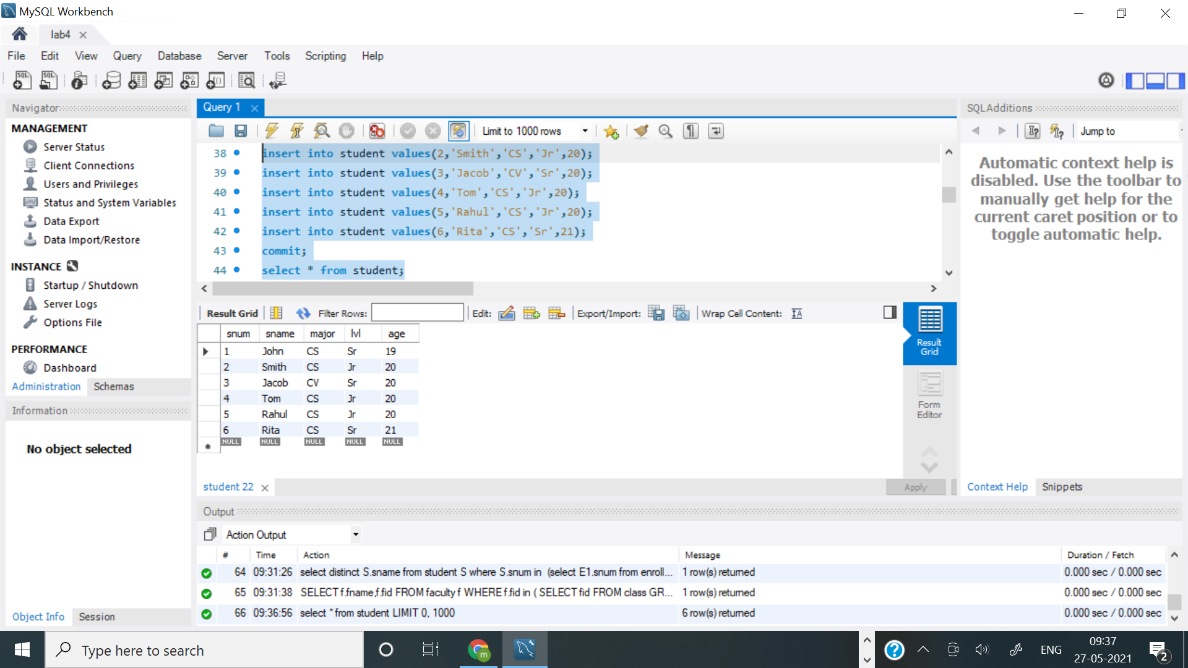

**Faculty Table:**

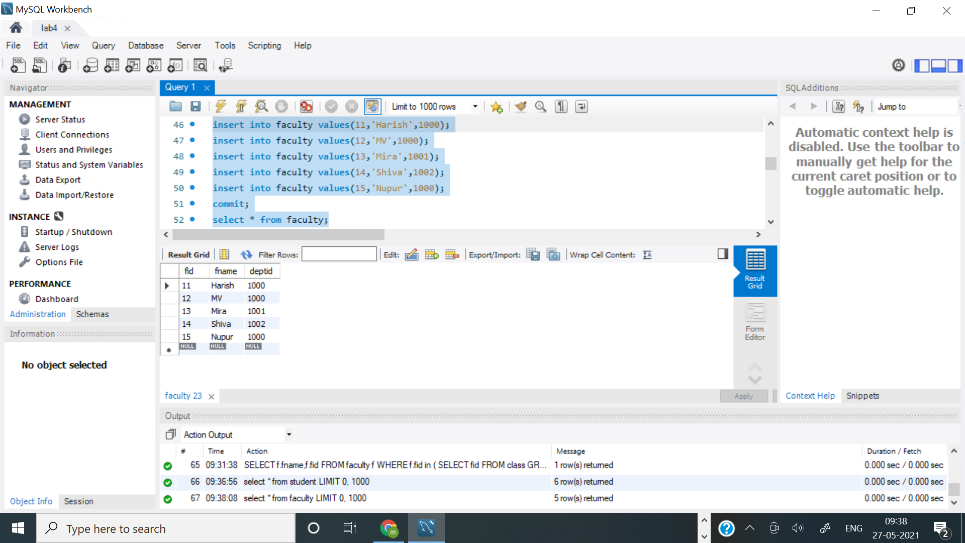

**Class Table:**

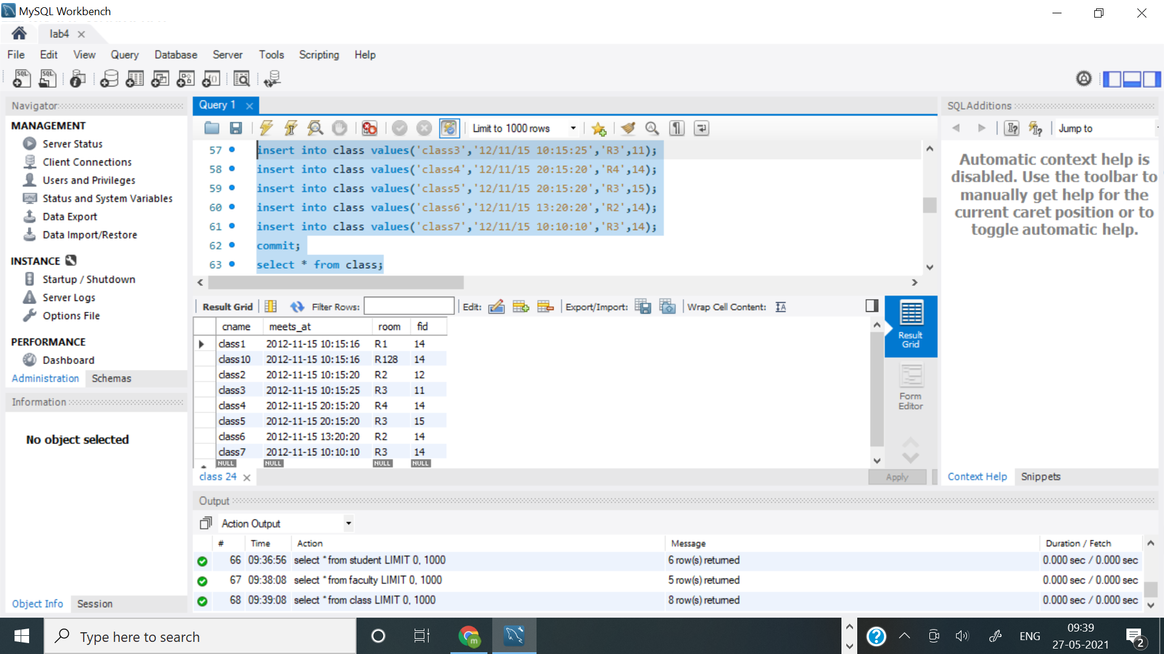

**Enrolled Table:**

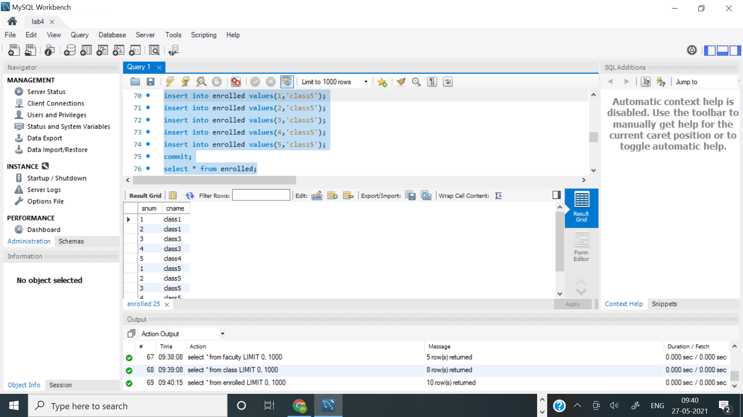

**Query 1**

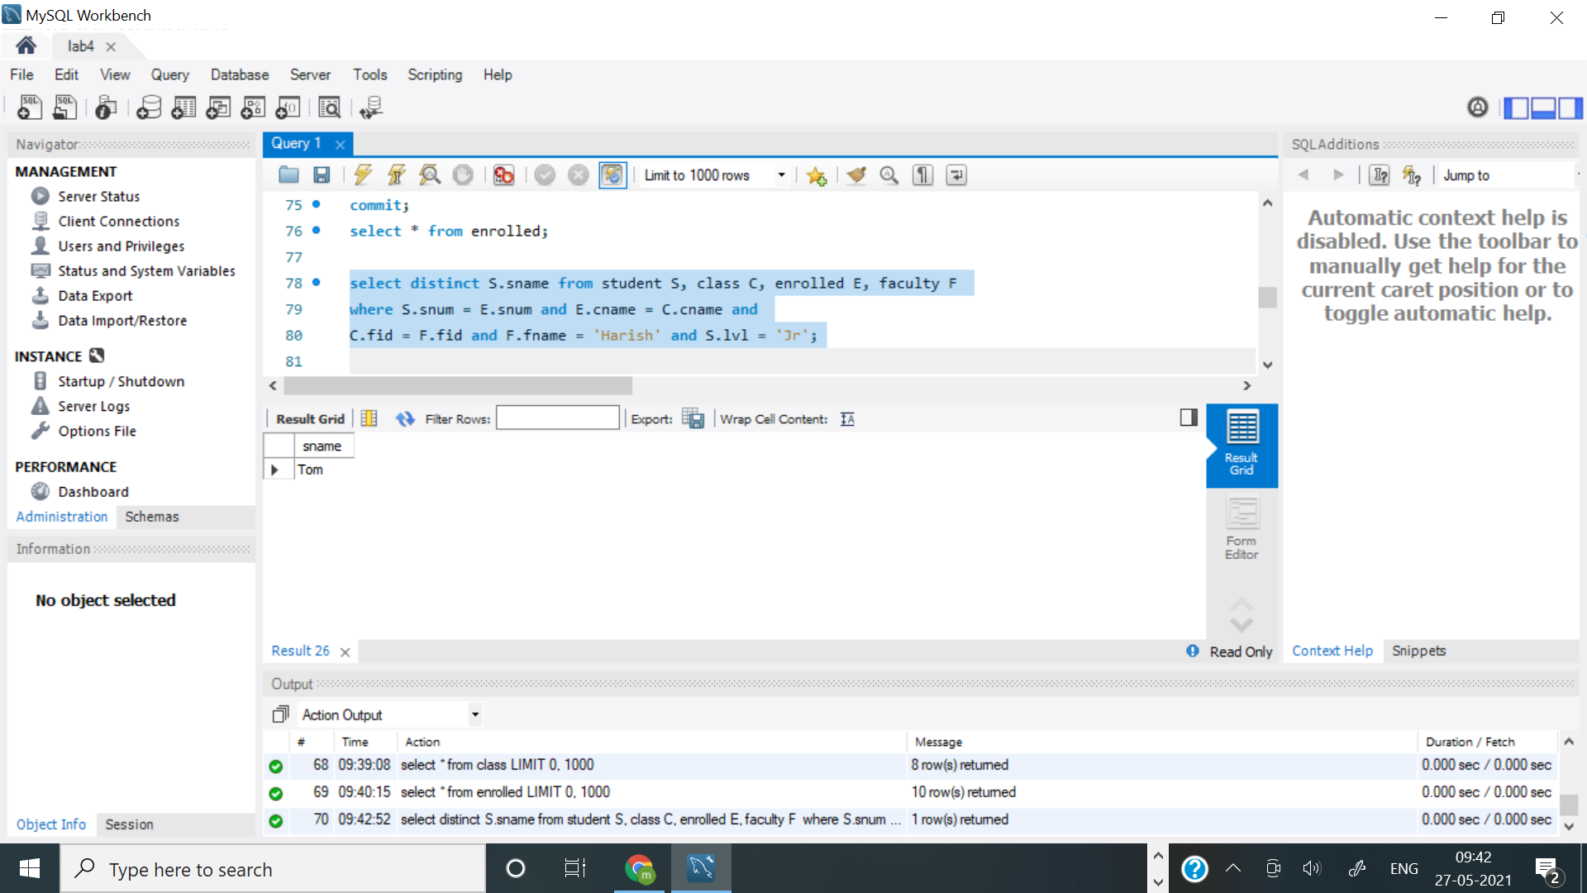

**Query 2:**

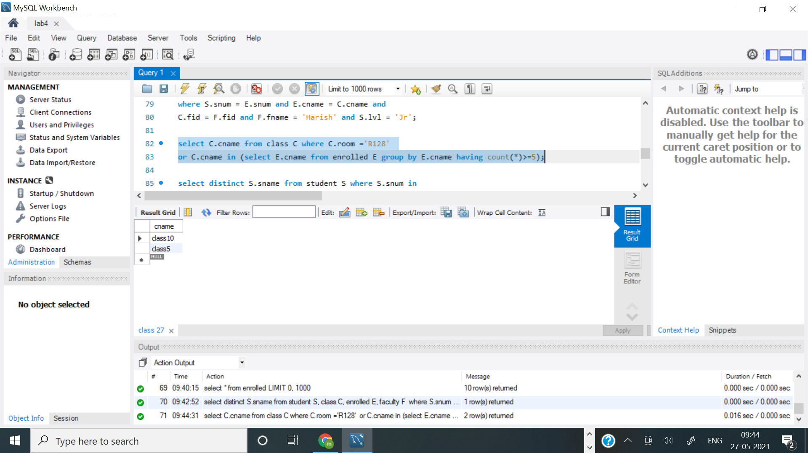

**QUERY 3:**

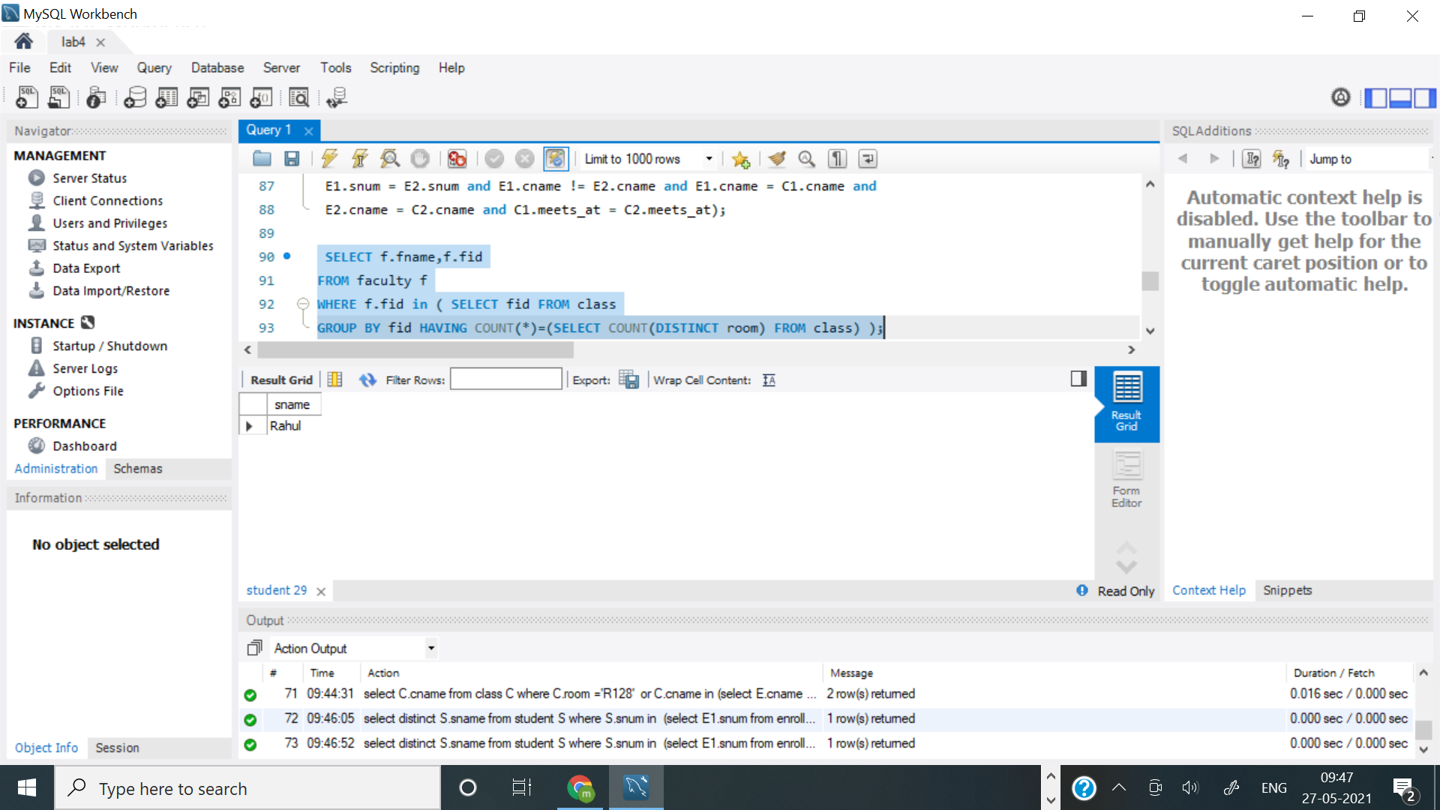

**Query 4:**

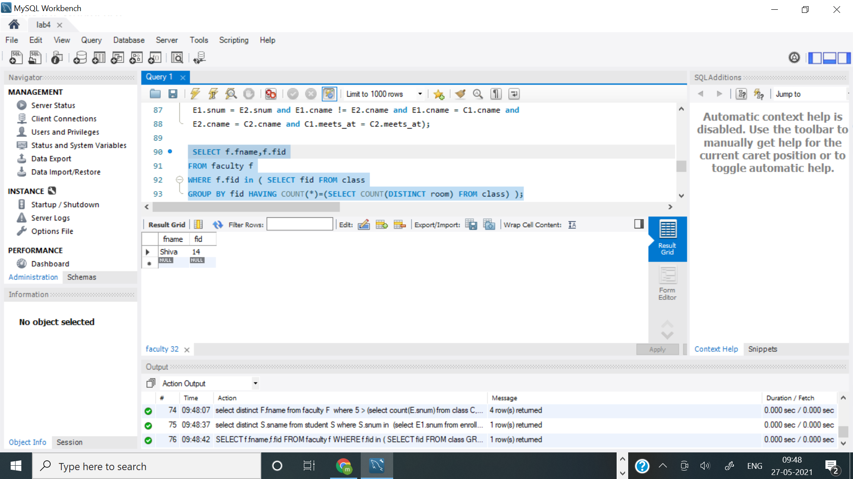

**Query 5:**

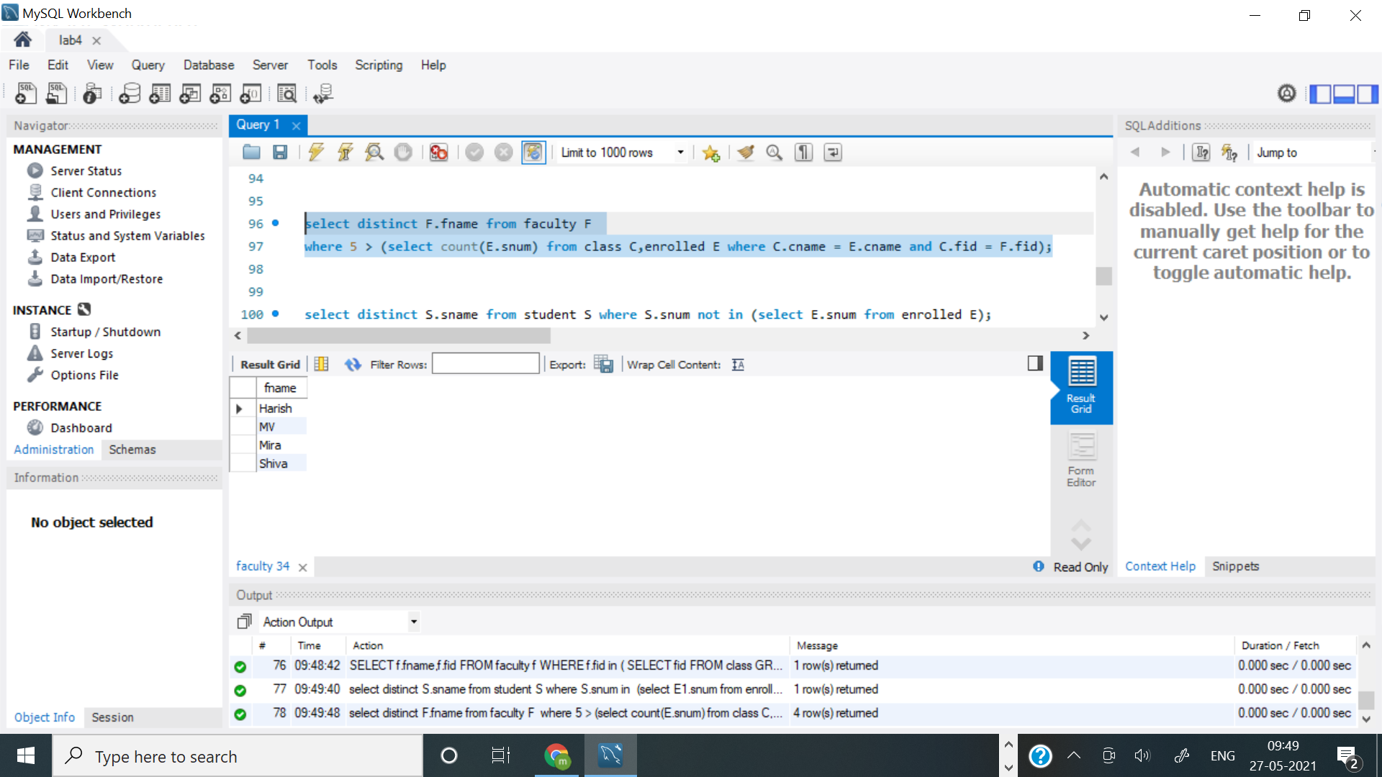

**Query 6:**

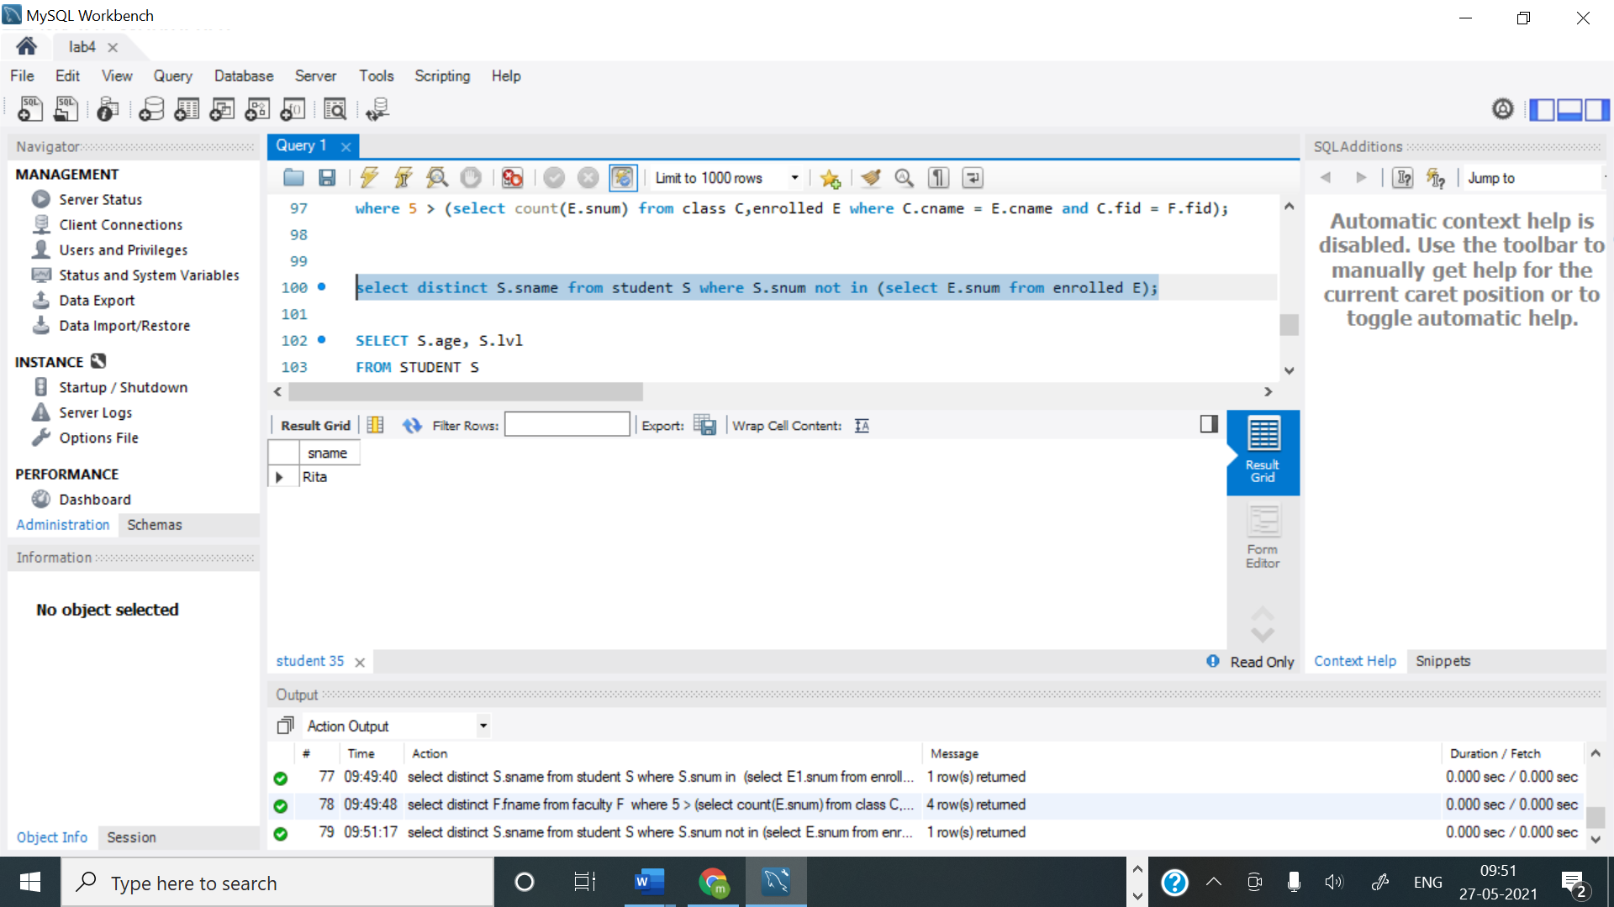

**Query 7:**

